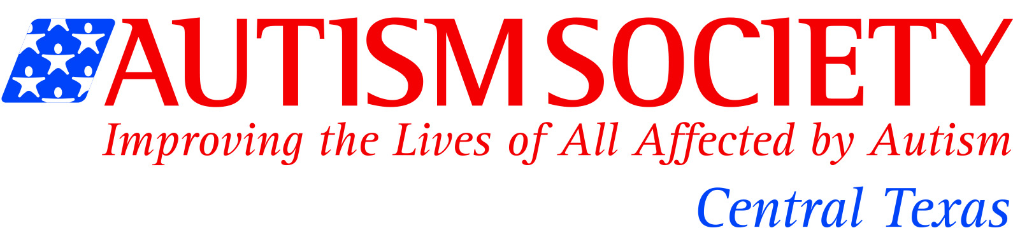
For IMMEDIATE RELEASE: Contact: Suzanne Potts
619-994-1871 cell
suzanne@austinautismsociety.org
Autism Society of Central Texas Statement on Autism

Austin, TX, August 29 2016- Recent remarks by San Antonio District Attorney Nico LaHood linking causes of autism to vaccines raised questions about the causes and cure for autism spectrum disorder (ASD). While much is speculated about the cause and cure of autism, science continues to indicate that there is no one known cause for this disorder. The Autism Society is about hope and support for people living with autism, providing information and referrals, support, education, advocacy and community inclusion opportunities for individuals with ASD and their loved ones. We strongly encourage families to work with their physicians and medical professionals to make informed decisions for their child. We feel what is more important than discussing the cause is the longitudinal support needed for an estimated 300,000 or more individuals with ASD living in Texas. What we do know is there are thousands of adults living with autism in Texas who struggle to receive critical services and support to have the best quality of life possible. Texas continues to rank 50 out of 51 states for services for people living with disabilities. The increasing number of individuals with autism on state service waitlists continues to grow and adults with autism continue to be underemployed or unemployed. We must do better by Texans living with autism by improving access to services instead of focusing on a cause or a cure.
The Autism Society of Central Texas is focused on positive outcomes, improving quality of life and support across the lifespan for an individual with autism. We encourage families to continue to be informed and educated about ASD by working with a trained medical professional before making decisions for their loved one.

About Autism
Autism is a developmental disability that usually appears in the first three years of life. Autism is a “spectrum disorder” meaning that it looks different in different people. In general though, people with autism typically have severe difficulties with communication, behavior, and social relationships. The incidence of autism has increased in recent years to an approximate occurrence of 1 in 68 births -- nearly twice as great as the 2004 rate of 1 in 125 – and almost 1 in 42 boys. Autism continues to receive more attention and as a result has opened opportunities for the country to consider how to serve families facing a lifetime of supports for their children.

About the Autism Society of Central Texas
The Autism Society of Central Texas is one of 100 affiliates of the Autism Society of America (ASA), the nation’s leading grassroots autism organization. ASA has been around nationally for over 50 years and last year the Autism Society of Central Texas celebrated 25 years of supporting individuals with autism and families in Texas. The Autism Society mission is to improve the lives of all affected by autism through information and referral services, support, recreation, education, and advocacy. With the increase in prevalence of autism, the requests for help from our organization have also increased dramatically. The Autism Society of Central Texas serves a 24 county region including Bexar County and responds to inquiries about diagnosis, support, treatment, biomedical interventions, educational options, local resources and more. We support thousands of individuals with autism and their families each year. The Autism Society of Central Texas is a 501 (c) (3) nonprofit organization. Donations are tax-deductible to the fullest extent of the law.

